Cymbidium Amazing x Cymbidium dayanum f. alba
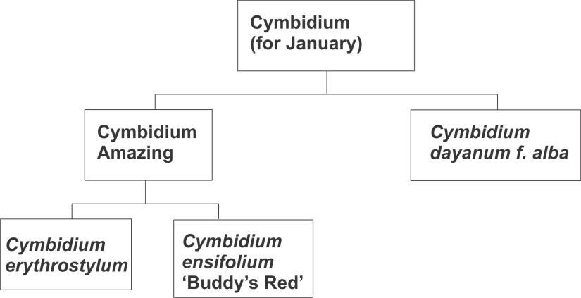
Six flowers on one arching 310 cm. inflorescence.
Natural spread horizontal 6.5 cm.
Natural spread vertical 6.5 cm.
Plant small 250 cm. tall.
Plant about 800 cm. in diameter.
Substance firm.
Texture satin.
Sepals and petals are very pale chartreuse on a cream base.
No odor detected.

